NAME____________________________LAB MEETING DAY/TIME______________

Lab 9: The Cordilleran Orogeny - KEY

In this lab you will continue to examine geologic maps and explore the development of the North American continent in the Mesozoic. You will be completing Exercise 17 in your lab manual.

# **Pre-Lab Questions**

**To prepare you for this lab, here are a few review questions to get you thinking about the Cordilleran Orogeny. Use your textbook or the lab pre-reading to answer these questions. If you use online sources, cite them and use your own words.**

**What are the names and geologic timing of the three phases of the Cordilleran orogeny? On the map here, shade in the general regions for these three phases and label them.**

|  |  |
| --- | --- |
| **Phase Name** | **Phase Timing** |
| **Sonoma (students aren’t required to include this one, but some will that listened in lecture….)** | **Late Permian – early Triassic** |
| ***Nevadan*** | ***Middle Jurassic to early Cretaceous*** |
| ***Sevier*** | ***Cretaceous*** |
| ***Laramide*** | ***Late Cretaceous to early Cenozoic*** |

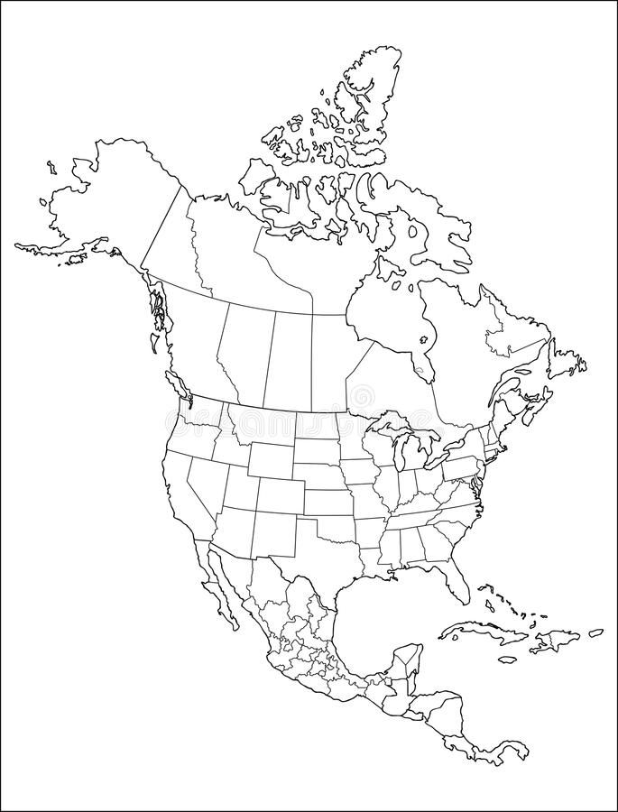

***Bighorns***

***Black Hills***

***Yosemite***

***Chouteau, MT***

# **Exercise 17, Part A**

**Mark / label the approximate location of Yosemite National Park on the map above; this is the area we are reviewing in this part of the exercise.**

**Question 1. Use the map and its legend to answer this question. Circle one**

*intrusive igneous extrusive igneous sedimentary metamorphic*

**Question 2. You may have to do some outside research to answer this question. Answer in your own words and cite your source.**

*From NPS.gov: ”Granite contains mostly potassium feldspars and has a low percentage of dark iron and magnesium minerals. In contrast,* ***granodiorite contains more plagioclase (calcium and sodium) feldspar than potassium feldspar and has more dark minerals.*** *Thus it is a darker color than granite.”*

**Question 3. Use the map and its legend to answer this question.**

***Cretaceous (K) Period.***

**Question 4.**

***The igneous rocks are different rock types, and different ages, indicating successive intrusions over a long period of time formed the intrusive rock complexes (batholiths).***

**Question 5. You may need to refer to your textbook for this one…what tectonic processes forms the rock types seen here?**

***Convergence (oceanic-continental). Subduction and melting of the Pacific Plate.***

**Question 6. SKIP this question.**

*These are the Paleozoic host rocks into which the magmas intruded.*

**Question 7. Use your answer to question 3, and the pre-lab questions on the previous page to answer this question.**

***Nevadan orogeny phase of the Cordilleran orogeny.***

# **Exercise 17, Part B**

**Read the introduction to this activity. Mark / label the approximate location of Chouteau, Montana on the map on the first page of this lab; this is the area we are reviewing in this part of the exercise.**

**Question 1. “Fabric” means the orientation and shape of the mountain ranges.**

***Linear ridges and valleys, parallel to one another***

**Question 2. Summarize the rock types / ages for this question, using the map legend.**

***More than 15 bedrock formations crop out in the map area. These range from Devonian to Cretaceous in age. Not all geological systems are represented however, as Pennsylvanian, Permian, and Triassic rocks are not present.***

* ***The Paleozoic age formations are predominantly marine limestone with minor amounts of marine shale and sandstone.***
* ***The Jurassic marine deposits of the Ellis Group are overlain by nonmarine, dinosaur bearing shale, sandstone, and conglomerates of the Morrison and Mt. Pablo Formations.***
* ***The Cretaceous are marine and coal-bearing marginal marine (deltaic and beach) deposited in the foreland basin of the Sevier orogeny.***

**Question 3.**

***The oldest formation is Devonian in age and is labeled Ds on the map, but described as Devonian rocks undivided on the map legend.***

**Question 4.**

***The youngest pre-Quaternary formation is the Cretaceous Horsethief Formation.***

**Question 5. Review page 205 of the lab manual to understand the map symbols. Focus on drawing the orientation of the thrust faults.**

***Cross section should be a simplified version of below. What is important is to recognize the angle and number of thrust faults, ages of the rock in the thrust blocks, and the flatter plain to the east.***

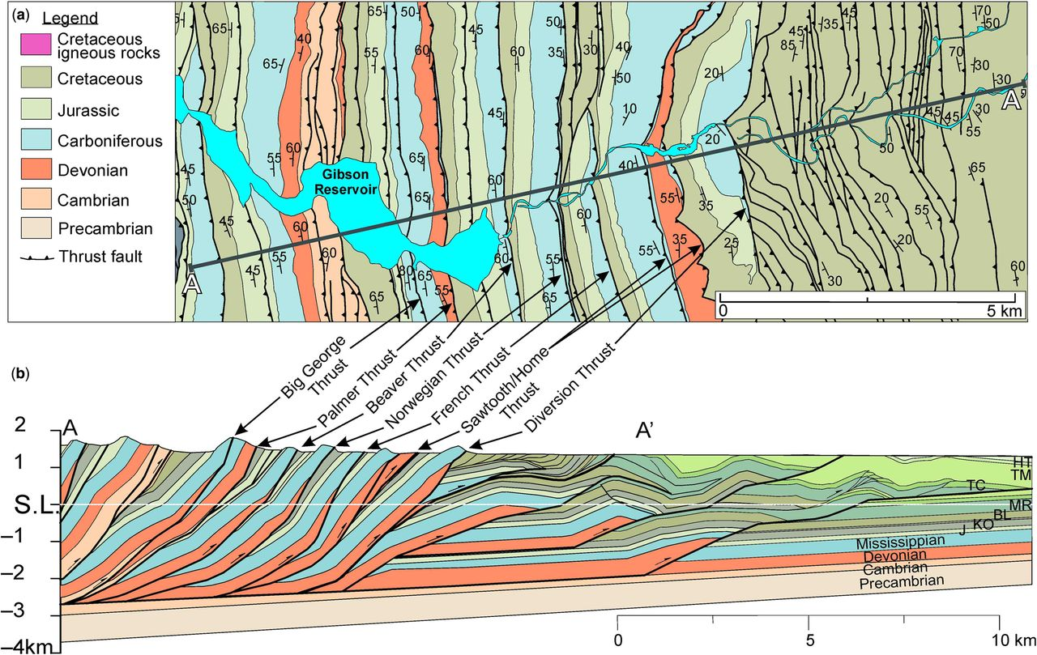

***Source:*** [***https://www.lyellcollection.org/doi/10.1144/sp487.6***](https://www.lyellcollection.org/doi/10.1144/sp487.6)

**Question 6.**

***The geology may seem complex to beginning students, but the folding and faulting is not extreme, so perhaps it is better to have them describe the fact that east verging thrust faults are the dominant structural feature and that it has completely affected the west two-thirds of the map area.***

**Question 7. Note that on the map, north is up / at the top of the map.**

***Thrust sheets were transported from west to east.***

**Question 8. Think about the ages of the rocks present. Also, note that the Quaternary sediments cover the faults in some places.**

***The youngest rocks involved in thrusting are Cretaceous in age, so it occurred after deposition of the Horsethief Formation. The Quarternary sediments covering the faults in some areas mean it occurred before then. There are no Cenozoic rock units to constrain the age.***

***Best answer –Cretaceous***

**Question 9. Use your answer to question 8, and the pre-lab questions on the previous page to answer this question.**

***Seiver phase of the Cordilleran Orogeny***

# **Exercise 17, Part C**

**Read the introduction to this activity. Mark / label the approximate location of the Bighorn Mountains, Wyoming on the map on the first page of this lab; this is the area we are reviewing in this part of the exercise.**

**Question 1. Review the cross section below, instead of drawing your own. Use this to answer the question.**

***Dome or anticline, oldest rock in center***

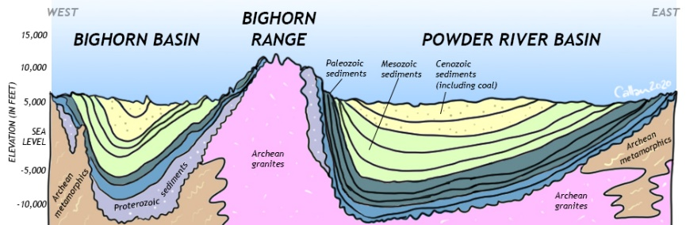

*(Image source:* [*https://opengeology.org/historicalgeology/case-studies/western-mesozoic-orogenies/*](https://opengeology.org/historicalgeology/case-studies/western-mesozoic-orogenies/)*)*

**Question 2. Use the cross section above, and the map in the exercise to think about this question: These are either domes or basins. Which are they, and how do you know?**

***Basins, youngest rock in center***

***Ages are Cretaceous to early Cenozoic***

**Question 3. Use the cross section below, from the area just south of Worland on the map to help you answer this question. The Cenozoic rocks in this region are not folded – what does this tell you about the timing of deformation?** Write your answer to the right of the cross section.

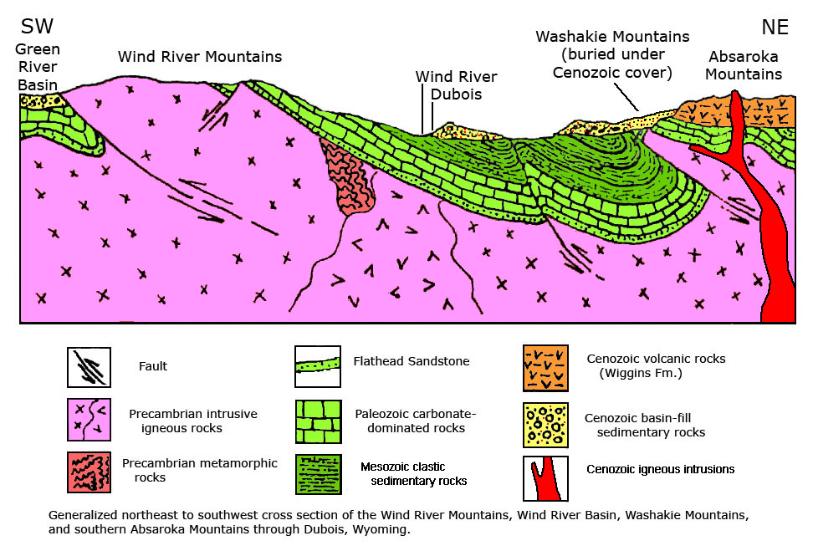

***Laramide Orogeny, occurred after Mesozoic deformation, but before Cenozoic sedimentary rocks***

**Question 4. Refer back to figure 17.5 on page 254 of the lab manual to answer the first question. Then refer back to pages 220 – 221 to answer the second question.**

***10,000 ft. These Precambrian rocks are part of the Archean-age Wyoming Province.***

# **Exercise 17, Part D**

**Read the introduction to this activity. Mark / label the approximate location of the Black Hills, South Dakota on the map on the first page of this lab; this is the area we are reviewing in this part of the exercise.**

**Question 1. Use the map on page 270, and the legend on pages 268 – 269 to answer this question.**

***Precambrian to Tertiary***

**Question 2. Refer to your textbook Appendix D on sedimentary structures, and think about the ages of the rocks in the circular structure to answer this question.**

***dome, with oldest rocks in the center.***

**Question 3. Use the map and legend to answer this question; fill in the table below.**

|  |  |
| --- | --- |
| *Area* | *Rock Type(s)* |
| *Core of Black Hills* | ***Mostly granite and other igneous intrusions*** |
| *Flanks (edges) of Black Hills* | ***Limestones, sandstones, shales, mudstones*** |
| *Plains to east* | ***Shales and limestones*** |

**Question 4. Think about your answer to the question above to answer this one. The core and flanks represent the uplift, and the plains were deposited after the uplift.**

***Tertiary (early Cenozoic); tertiary rocks are not folded, but the Pierre shale is folded; so it occurred sometime between the two.***

**Question 5 & 6. SKIP these questions.**

# **Exercise 17, Part E – SKIP THIS PART**

# **Exercise 17, Part F**

**Read the introduction to this activity. Using Figure 17.13 shade / mark the general location of these rocks on the map of the first page of this lab.**

**Question 1. A lithofacies map shows the different rock types of an area. To construct this map, choose a color for each of the rocks discussed in the introduction to this section. Color the dots for those, and then shade in the regions for each rock type. Include a legend below.**

***Lines represent boundaries on the map below. Students should shade in each region and provide a legend for their colors.***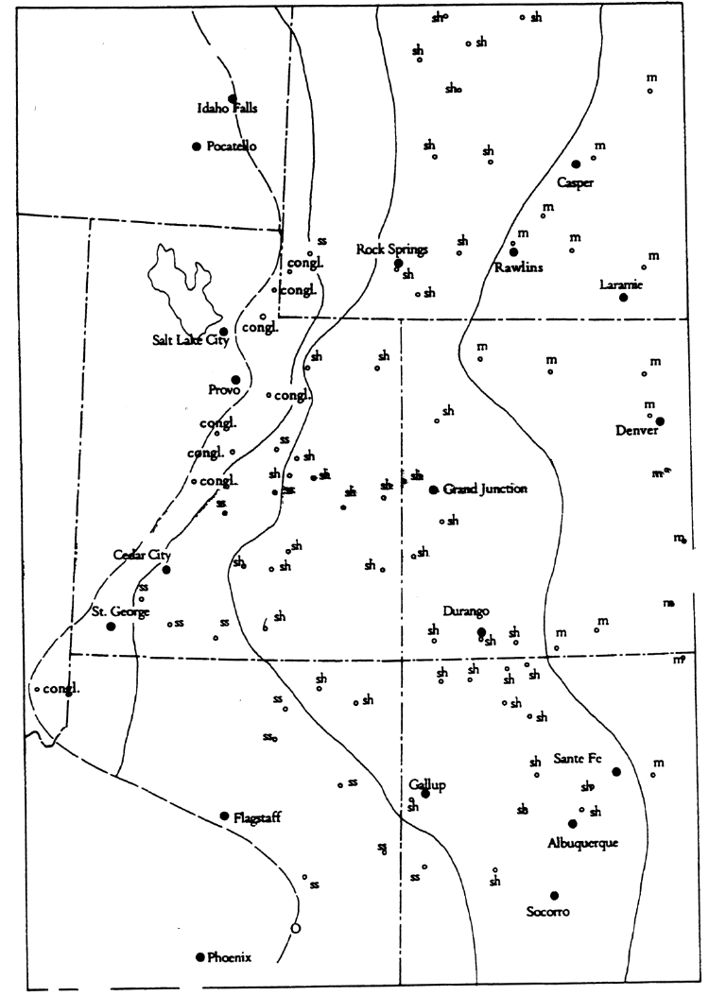

**Question 2:**

***Yes, they parallel the zero thickness line***

**Question 3: Think about your answer to question 2 to answer the first question, and the map you’ve been filling in on the first page of the exercise for the second question. Also suggest the orogeny that provided the sediments here.**

***West to east. Sevier Mountains of central Utah (mountains to the west)***

**Question 4. Skip this question.**

*The answer is no, because the Colorado Rockies formed in the Cenozoic. But that is not evident in this map.*

**Question 5. Think about how sediments accumulate, and what thickness you would expect nearest their source and furthest from their source.**

***Through the middle of the map, due to subsidence to the east (inland) of the Sevier Thrust belt.***

***(students should thinking about timing of the deposits shown in the map to answer this question.***

# **Lab 9 Reflection**

**What concepts were most difficult in today’s lab activities?**

***Any answer is okay, as long as it shows some reflection.***

**What concepts were easiest to grasp?**

***Any answer is okay, as long as it shows some reflection.***

**What questions did today’s activities make you think of? What do you want to learn more about?**

***Any answer is okay, as long as it shows some reflection.***